lnvestigation of Data Path Simulator Being an Efficient Teaching Tool
Shihao Fan
The prospect of computer science in recent decades has attracted social attention; regardless of financial reasons or technological advancement pursuits, the focus of government support moves towards the computing industry. As a result, there has been a tendency during past years for more students to choose to study computer science as one of their major courses, especially in their high school life (McDonald, 2022). I have decided to construct a computer system simulator which could efficiently help students keen to learn computing understand the foundational operation of the computer system. The simulator is to satisfy some students' desire to dive deeply into the computer system while providing elementary information for lower-level students.

I mainly chose this title because I found my classmates struggle to understand and demonstrate the inner workings of the computer, rather than the algorithm investigation and application, due to the lack of practical experience and opportunity. Therefore, I wonder if a simulation of computer working will benefit computer science students to comprehend the basics of the computer system, since a proficient hardware comprehension is essential for being a computer engineer. (Adrian, 2010)

Since the final product is an educational simulator, it is vital and worthwhile to acquire accurate information about the fundamentals of computer systems, followed by some brief research on the visualisation of programming to realise the simulation. In this way, it can minimise the possibility of imparting misleading information while maintaining aesthetic attributes. In the aspect of small gadgets, existing similar simulator products would facilitate the inspiration process, which also could improve my final product by learning substitutes' strong points while offsetting their weakness. To apply my ideas to the final product, I would also find support plugins on forums, such as GitHub, to resolve obstacles I cannot cope with. To conclude, I want to use all the information I have obtained and produce a computer simulator which could benefit students in understanding the underlying principles of the computer.

User Requirements Identification
According to the suggestions from experts in the education industry and past investigations, animations (Bairstow, 2023) and visualisations on electronics (Twissell, 2018) are essential to make knowledge vivid and intriguing. Besides investigations on the application layer, the complexity of the data path and simulation process is also a crucial factor in evaluating the success of a simulator, because it determines the upper limit of the functionalities of the simulator.

To specify a sophisticated success criterion, I decided to interview the potential users, which would be a primary resource for me investigating the virtual expectations of the product. The table below summarises the interview I conducted with an experienced computer science teacher (Rood, 2024), who gave invaluable advice and discussed the desired functionalities of the simulator overall.

Question | Answer
Features expecting to see in the simulator’s user interface | There is a similar program called “The Little Man”, which simulates the working procedure of assembly language but lacks details on imitating the working of the computer system. Therefore, it is essential to populate appropriate visualisations supporting the simulation, such as demonstrating data path operations and applications of general-purpose registers. Additionally, a detailed Arithematic Logic Unit would be helpful to ground students in fundamental mathematic operations in computers. From the perspective of linking components in the simulator, addressing buses (data, address, and control) can make the simulation more persuasive. As an extension, allowing customisation of clock speed and implementing cache memory are good topics to focus on, as they benefit pupils to understand further concepts.
Level of supports and documentation accompany the simulator | Since the simulator performs the role of assisting A-level computer science studying, the assembler should include the instructions specified by the document published by AQA (AQA, 2015). Hence, a reference of the document is sufficient for demonstrating the assembler, though an extra manual could be created for more explanations. Moreover, drop down menu can be implemented for standardising the instructions. Some tip boxes can be designed to hop over the interface which demonstrates how each section works.
Expectations on functionality of the assembler | The exist similar programs are having limited instruction sets, which even barely contains full A level instruction sets. As a result, it is highly demanded for the simulator to have a completely furnished assembler supporting an integrated assembly language instruction set.

Upon the interview results above, I concluded the following requirements and expectations for my project:
- Having a complete implementation of AQA Assembly Language Instruction Set on the simulator.
- Demonstrating data path execution cycle to users.
- Facilitating user interactions with the simulator for enhancing practical experience.
- Attempting to optimize the performance of the simulator.
- Helping students understanding the concept of execution cycle and data path.

Research
After I have done investigations on similar programs (see Appendix), I came up with the following designs and implementations.

Computer components
In addition, I have done research on basics of compute system including elaborate electronic circuits within the data path. I noticed that combinational logic and synchronous sequential logic are fundamental logic circuits in computers (Mano & Ciletti, 2018), which many other contemporary circuits built upon them (Katz, 2005). To consolidate my understanding and demonstrate the gadgets, I developed few circuits, using a circuit simulator tool (CircuitVerse - Digital Circuit Simulator Online, n.d.), based upon the design available online (O'Neal, 2014) and written in books (Mano & Ciletti, 2018):
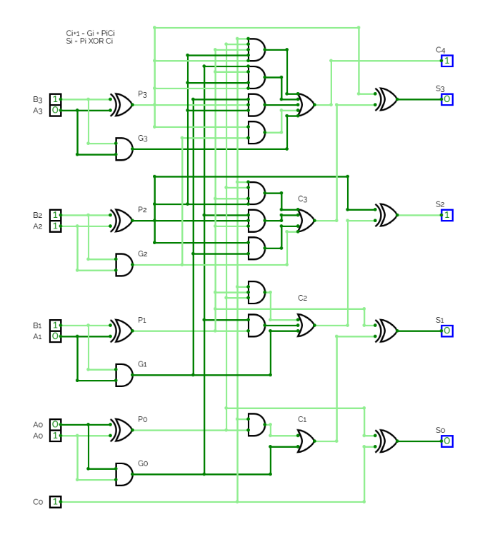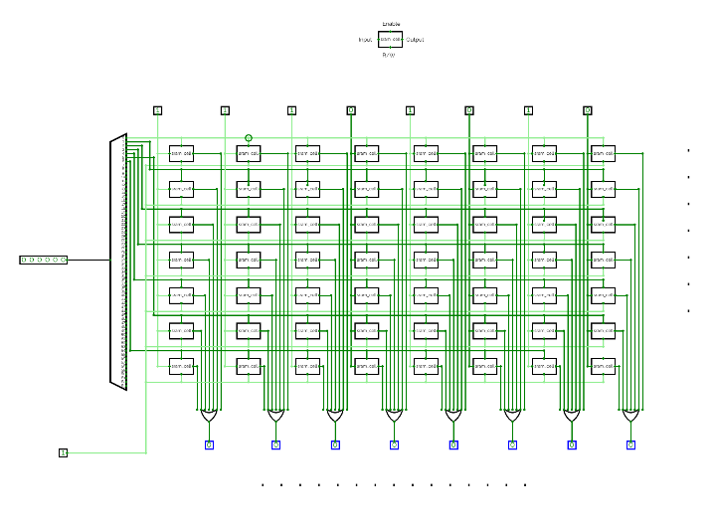
Figure 1 & 2: Adder with Look Ahead Bit; SRAM
The adder shown in figure 1 introduced an optimisation idea, where a bit is delivered forward within a clock time rather than passing through different adder blocks. Specifically, the carry bit is calculated using: $G_{i}=A_{i}∧B_{i}$
$$P_{i}=A_{i}⊕B_{i}$$
$C_{i+1}=G_{i}+P_{i}∧C_{i}=G_{i}+P_{i}\left(G_{i-1}+P_{i-1}∧C_{i-1}\right)$……
Consequently, more wires and logic gates are used, which trades out costs for efficiency.
Furthermore, the Random Access Memory in Figure 2 is the same one being used in my data path simulator. A large decoder is used to choose access granted memory address, while 16 number of mux is implemented at the bottom for outputting data. However, since the logic of each memory unit is identical, I only placed 7 memory units each with 8 bits word rather than 512 units each with 16 bits word (capacity of memory in my simulator), otherwise the illustration would be redundant.

Implementation

Data Path and Visualisation
The data path simulator starts from a bespoke data path design. A sophisticated existing design is the best source of inspiration and reference, since my experience is not sufficient to support me to develop a computer data path from scratch. Therefore, on the behalf of adaptation, I facilitate the following diagram, built upon the existing architecture (Patt & Patel, 2020) and modified it for my own implementation:
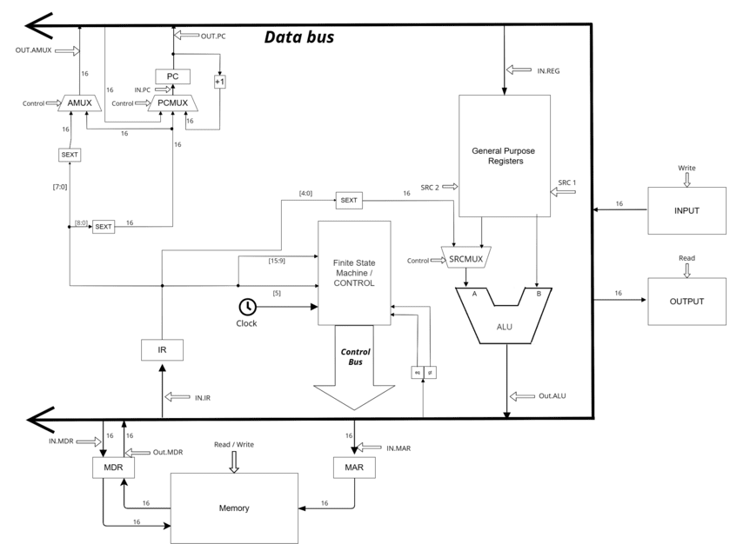
Figure 3: Data Path Implementation
The data path is split into two sections: Program Control Unit on the left (e.g., Program Counter and Finite State Machine) and Arithmetic-logic Unit (e.g., ALU and registers) on the right. In terms of synchronisation, a clock is set and directly sending signals to the Finite State Machine, which is reponsible for managing state and gates of the machinery. Moreover, the Memory and its relevant registers are designated outside the core, so that it manifests the fact that Memory is not a part of the CPU.
Due to clarity considerations, only data bus is shown on the diagram, while control bus is expressed implicitly. Nonetheless, control signals for combinational logics are still labelled. On top of that, the latest comparison result of equality and greatness of two variables are stored in two registers EQ and GT in between data bus and Finite State Machine, thus it is eaiser for comparing and validating branching conditions.
Speaking of visualisations, the corresponding wire and control signals will be highlighted once they are being used and required by the current instruction execution. The highlighting functionality utilises different colours to represent status and each stage of execution. In this case, blue represents the wire being used in decode stage, while yellow symbolises the one functioning at fetch stage, and red illustrates the one functioning at execution stage, along with orange representing both. Additionally, green highlighting shows the availability of control signal, usually TRUE signal, at the component.
Screenshots of working example is listed below:
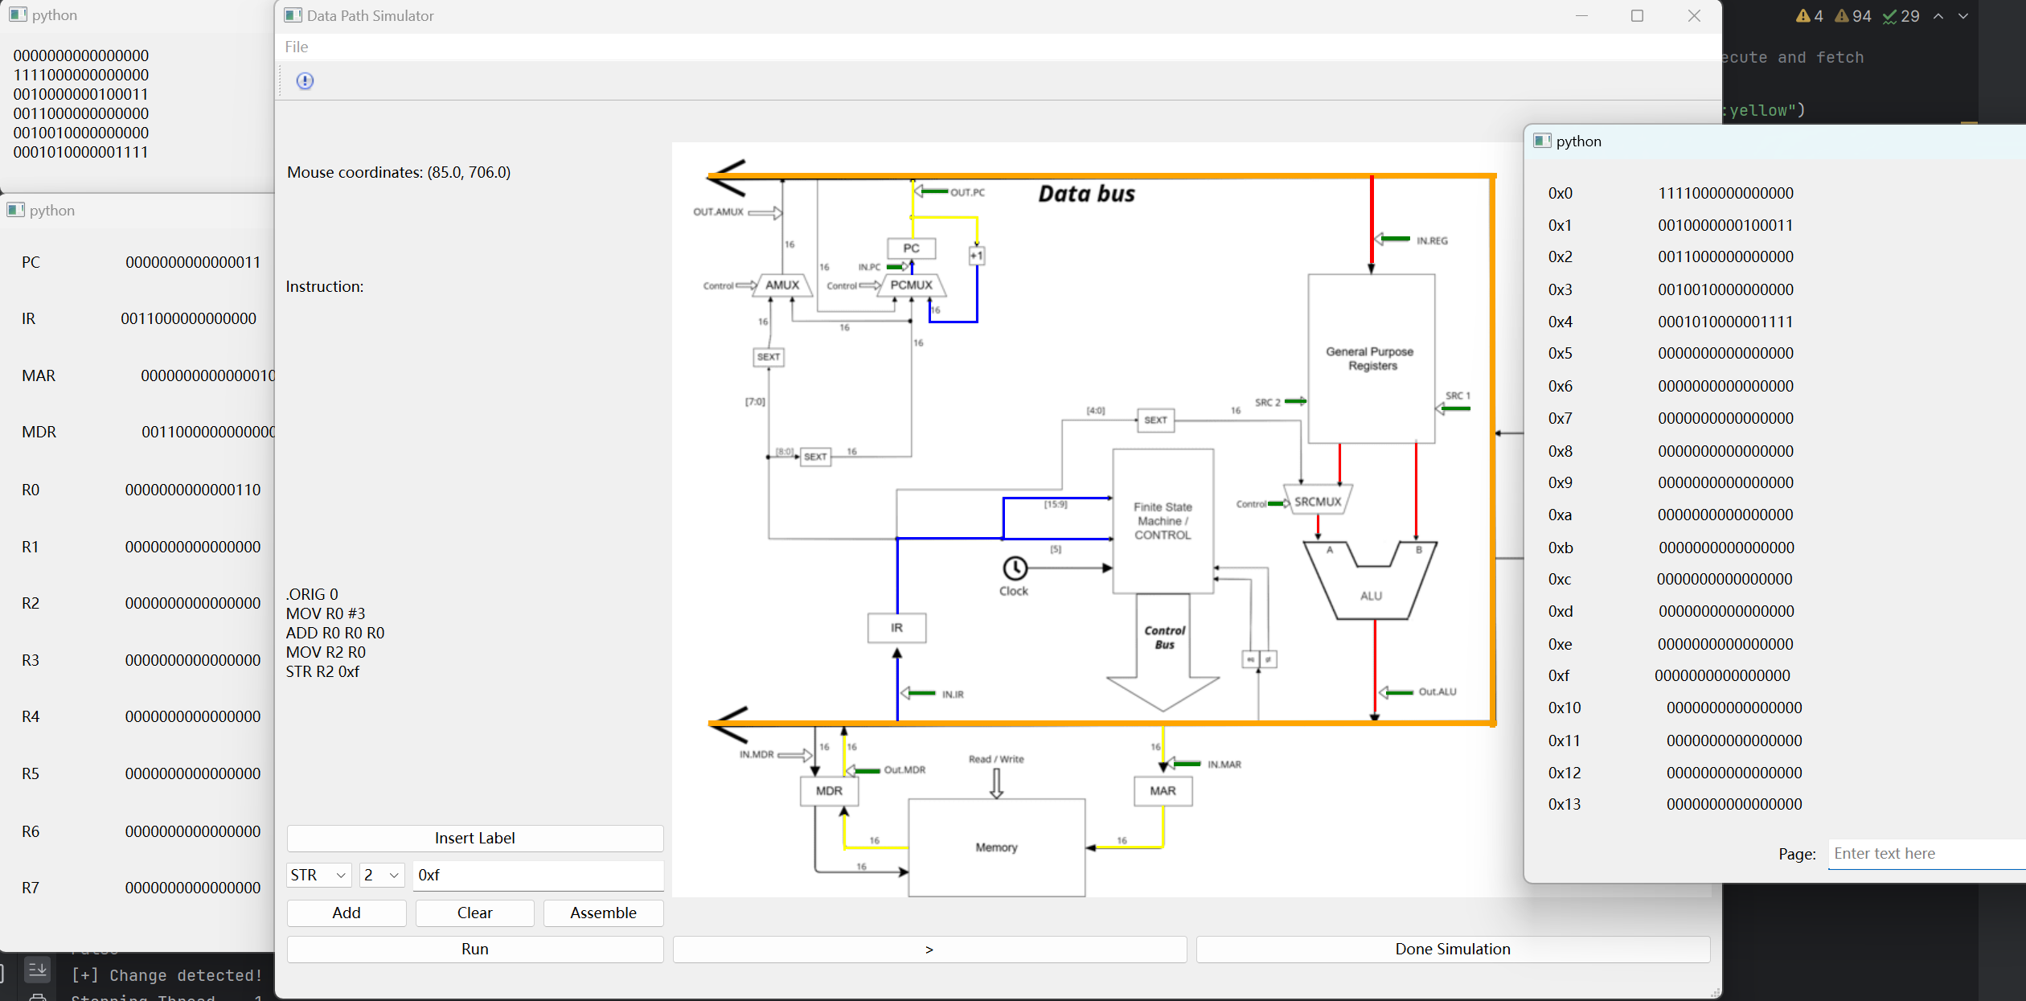
Figure 4: Simulator running MOV instruction
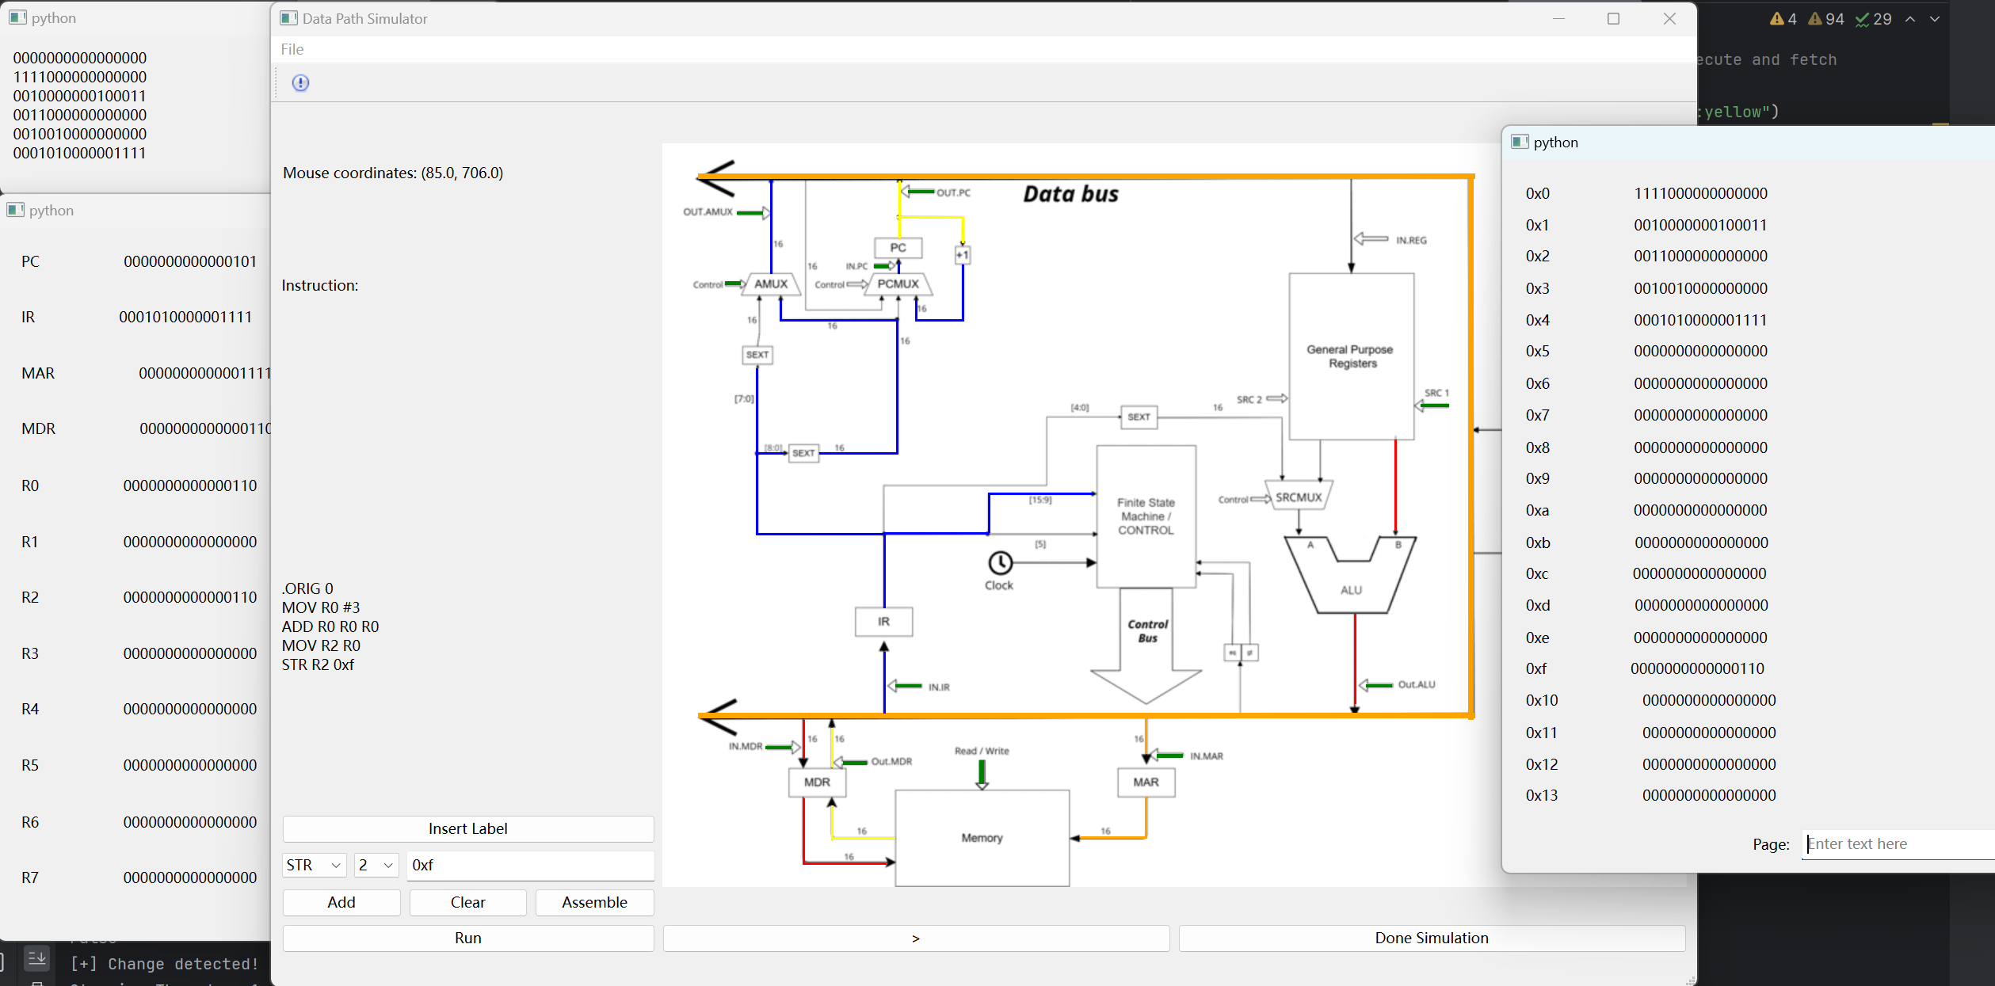
Figure 5: Simulator running STR instruction

Assembler and control unit code
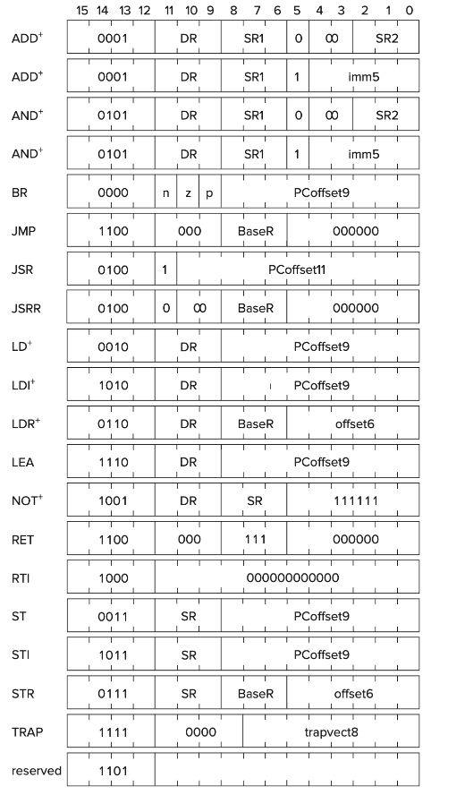
Because of the convenience and efficiency of pointer handling of C language, I had used C to develop both assembler and Instruction Set Architecture (ISA), as memory management is essential for the operation of both.
Besides, the scheme of assembly code is perfectly comformed with the standards in AQA A-Level Computer Science requirements (AQA, 2015), despite the length of each word is 16 bits. Beyond that, the immediate supports both decimal and hexadecimal input, so that the assembly code can be more readable and elegant. In addition, the instruction set architecture of the simulator is inspired by the implementation in LC-3 (Patt & Patel, 2020), shown in Figure 6, which is a well-refined machinary used for tutorial purposes. While maintaining the order and style of opcode and operand, I varied the memory operand into stating the memory address directly rather than providing PC-offset, conveniencing the branching system. Therefore, the data of memory address if is directly piped to the PCMux in my data path (Figure 5).
Figure 6: Instruction set of LC-3
Generally, the format of an instruction is (bit positions taken shown in the bracket):
Opcode [15-12] | RegisterTo  Conditions for MOV [11-9] | RegisterFrom/0  [8-6] | Operand Mode [5] | Immediate [4-0]  RegisterFrom2 [2-0]

Optimisation
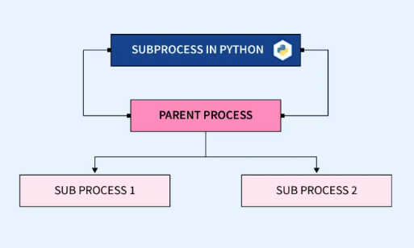
The initial phase of optimization focused on maximizing CPU and memory utilization. Initially, the C program didn't run concurrently with the Python code, which hindered development for some time. To resolve this, we implemented the use of subprocesses, treating the compiled executable as a child process of the Python program (Pandey, 2022). As a result, the assembler is triggered once the assembly code is ready, ensuring the machine code is promptly available for execution.The initial phase of optimization focused on maximizing CPU and memory utilization.
Figure 7: Logic diagram of subprocess
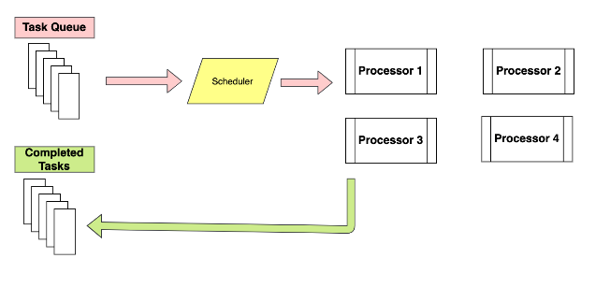
However, the existence of numerous child processes slows down the main process, reducing the responsiveness of the user interface. To address this, multiprocessing is introduced, utilizing multiple CPU cores to run programs concurrently. However, since each process has its own memory space, sharing parameters and variables between them becomes complex. To simplify this, a multiprocessing pool is used, which creates a central manager to enable shared lists across processes (Brownlee, Multiprocessing Manage Example in Python, 2022).
Figure 8: Working procedure of multiprocessing

Additionally, an issue arose where processes, such as the control unit, stopped responding promptly after multiple calls. The solution was to implement asynchronous processing, allowing a process to execute only when a signal is sent to the controlling queue (Brownlee, Multiprocessing Pool.apply_async() in Python, 2022). This enables the use of an infinite loop without the risk of freezing the program. Consequently, the control process halts as expected, providing greater flexibility for demonstration tasks between instructions in the simulator.

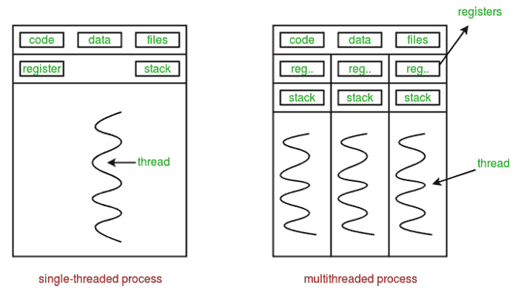
On top of that, the control unit must be constantly monitored to ensure immediate updates to displayed content whenever data is modified by instruction execution. To achieve this, an indefinite loop is necessary in the main process for continuous monitoring. Instead of opening a new process, multithreading is preferred in this situation. The new thread operates within the same namespace as the main thread, allowing the monitoring thread to signal the main thread, where updates and adjustments are then executed.
Figure 9: multithreading principles

In terms of algorithm optimization, I replaced a linear static list with a hash table in the assembler, significantly reducing the time complexity from O(n) to O(1) for locating memory addresses corresponding to label names.
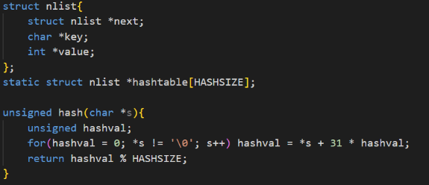
Overall, the implementation and optimization primarily focus on processes and architecture. The program is object-oriented, which clarifies relationships between objects and enhances the accessibility of existing functions for adding new features.
Figure 10: code snippet of hash table initialisation

Evaluation
The simulation performs well in both visualization and control from a developer's perspective. The program assembles the assembly code and runs it correctly and efficiently, while the visual representation clearly illustrates the working process.

One teacher remarked that the proficiency and functionality of the instruction set architecture and control unit are impressive, with the simulator supporting most of the expected operations. Additionally, the use of highlights for demonstrations was praised, as it clearly depicts the role of each component. In this manner, the application helped a lot on understanding computer machinary fundamentals. However, suggestions for improvement include adding more advanced features, such as animations for latches in memory units, to make the concept even more comprehensible.

On the other hand, a few students mentioned that the instructions for using the simulator were unclear, limiting its usability despite its strong practical capabilities. Therefore, providing detailed documentation alongside the program would be highly beneficial.

Conclusion
In general, compared to preset requirements and expectations, I believe my project demonstrates that the computer data path simulatior is a powerful and handy tool for learners to understand basics of computing, from both teachers’ and students’ feedback.
Speaking of artefact side, it meets many of the objectives set at the beginning of the project.
- Data path execution cycle is well demonstrated by highlighting out the working components, and audiences believe the tool has positive impacts on them.
- Users can input assembly code, which is under the specification of AQA A level Computer Science.
- The program is optimised for efficiency and proficiency using algorithms and maximise utility of CPU.
- Nevertheless, few expectations obtained from the interview have not realised, such as detailed demonstrations of ALU.
Overall, the most fascinating aspect of building the PC simulator, in my view, has been exploring the fundamental principles of computer science. The challenges encountered during development have sharpened my problem-solving and project management skills. This project not only impacts me but also benefits other learners interested in the computing field.

Bibliography
Adrian. (2010, December 29). Should a developer know the inner workings of the computers' hardware? . Retrieved from StackExchange: https://softwareengineering.stackexchange.com/questions/31719/should-a-developer-know-the-inner-workings-of-the-computers-hardware
AQA. (2015, 09). Assembly language instruction set. Retrieved from AQA: https://filestore.aqa.org.uk/resources/computing/AQA-75162-75172-ALI.PDF
Bairstow, N. (2023, 11 22). Animating education: a teaching tool that brings learning to life. Retrieved from Times Higher Education: https://www.timeshighereducation.com/campus/animating-education-teaching-tool-brings-learning-life
Brownlee, J. (2022, 8 31). Multiprocessing Manage Example in Python. Retrieved from SuperFast Python: https://superfastpython.com/multiprocessing-manager-example/
Brownlee, J. (2022, 7 9). Multiprocessing Pool.apply_async() in Python. Retrieved from Superfast Python: https://superfastpython.com/multiprocessing-pool-apply_async/
CircuitVerse - Digital Circuit Simulator Online. (n.d.). Retrieved 5 14, 2024, from CircuitVerse: https://circuitverse.org/about
dobbs. (2017, 5 1). Python Threading: Multiple While True loops. Retrieved from Stack Overflow: https://stackoverflow.com/questions/42499299/python-threading-multiple-while-true-loops
Gajski, D. D. (1997). Principles of Digital Design. Upper Saddle River, NJ: Prentice Hall.
Karthik. (2024, 4 9). A Beginners Guide to Multi-Processing in Python. Retrieved from Analytics Vidhya: https://www.analyticsvidhya.com/blog/2021/04/a-beginners-guide-to-multi-processing-in-python/
Katz, R. H. (2005). Contemporary Logic Design. Upper Saddle River, NJ: Prentice Hall.
Kaymak, S. E. (2023, 10 08). Mips-Datapath-Simulator. Github. Retrieved 05 17, 2024, from https://github.com/saliherdemk/Mips-Datapath-Simulator
Kernighan, B. W., & Ritchie, D. M. (1988). Structure. In B. W. Kernighan, & D. M. Ritchie, The C programming language (pp. 127-151). Englewodd Cliffs, N.J: Prentice-Hall.
Madnick, S. (1965). Little Man Computer. Retrieved 05 17, 2024, from https://peterhigginson.co.uk/lmc
Mano, M. M., & Ciletti, M. D. (2018). Digital Design With an Introduction to the Verilog HDL, VHDL, and SystemVerilog (6 ed.). Pearson Education.
McDonald, C. (2022, August 18). Fourth year rise in students sitting A-level computing. Retrieved from Techtarget: https://www.computerweekly.com/news/252523972/Fourth-year-rise-in-students-sitting-A-Level-computing
Multithreading in Python. (2024, 8 13). Retrieved from geeksforgeeks: https://www.geeksforgeeks.org/multithreading-python-set-1/
O'Neal, M. (2014, 5). Project Watson. Retrieved 8 3, 2024, from Project Watson: http://watson.latech.edu/book/circuits/circuits.html
Pandey, D. (2022, 11 3). Subprocess Module in Python. Retrieved from Scaler Topics: https://www.scaler.com/topics/subprocess-module-in-python/
Patt, Y. N., & Patel, S. J. (2020). Introduction to Computing Systems: From Bits & Gates to C/C++ & Beyond (3 ed.). McGraw Hill.
Record numbers of students choose Computer Science A Level in 2022. (2022, June 22). Retrieved from BCS - The Chartered Institute for IT: https://www.bcs.org/articles-opinion-and-research/record-numbers-of-students-choose-computer-science-a-level-in-2022/
Rood, S. J. (2024, 03 20). Facilities and Visualisations Neede for Aiding Computing Teaching. (S. Fan, Interviewer)
Twissell, A. (2018). Modelling and Simulating Electronics Knowledge: Conceptual Understanding and Learning through Active Agency. Journal of Educational Technology & Society, 21(2), 111-123. Retrieved from http://www.jstor.org/stable/26388384
Wapiti. (2015, 4 11). Basic multiprocessing with while loop. Retrieved from Stack Overflow: https://stackoverflow.com/questions/29571671/basic-multiprocessing-with-while-loop
Xiao, Z., Higgins, S., Kasim, A., & Ridgway, J. (2017). Seeing is Believing: Impact Visualisation in Educational Interventions. Durham: Durham University.

Appendix

Future Work
The visualization is not yet fully implemented. Engaging animations that dynamically demonstrate processes would be a more effective approach for an educational tool. Additionally, the electronic designs introduced earlier could be displayed when users hover over corresponding components, enhancing interactivity.

Regarding the simulator's performance, increasing word length along with memory capacity could significantly boost its development potential. This would allow the simulator to handle instructions used in modern computer architectures, such as x86 and ARM.

To improve user accessibility, detailed documentation should be provided, as novice users may struggle with the assembly code format and how to properly start the simulator.

Similar Programs Investigation
Before developing the product, it is important to investigate the similar product, so that they can inspire me on designing of my product. Hence, I investigated a few simulators and summarised their worth-learning part and possible improvements.

Mips-Simulator using JavaScript:
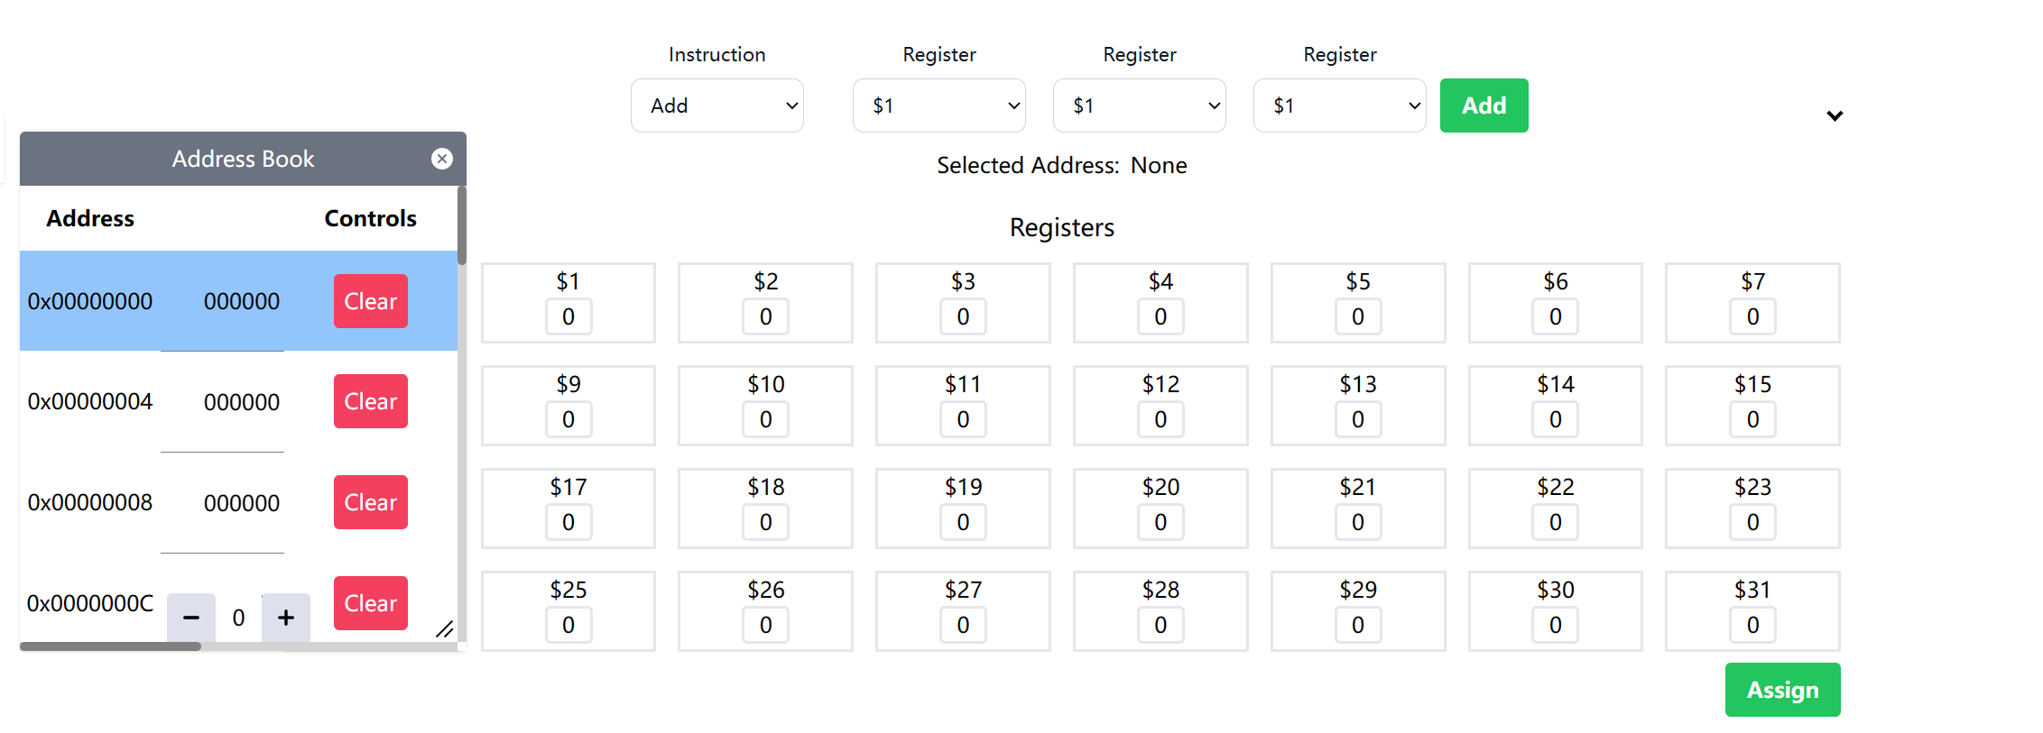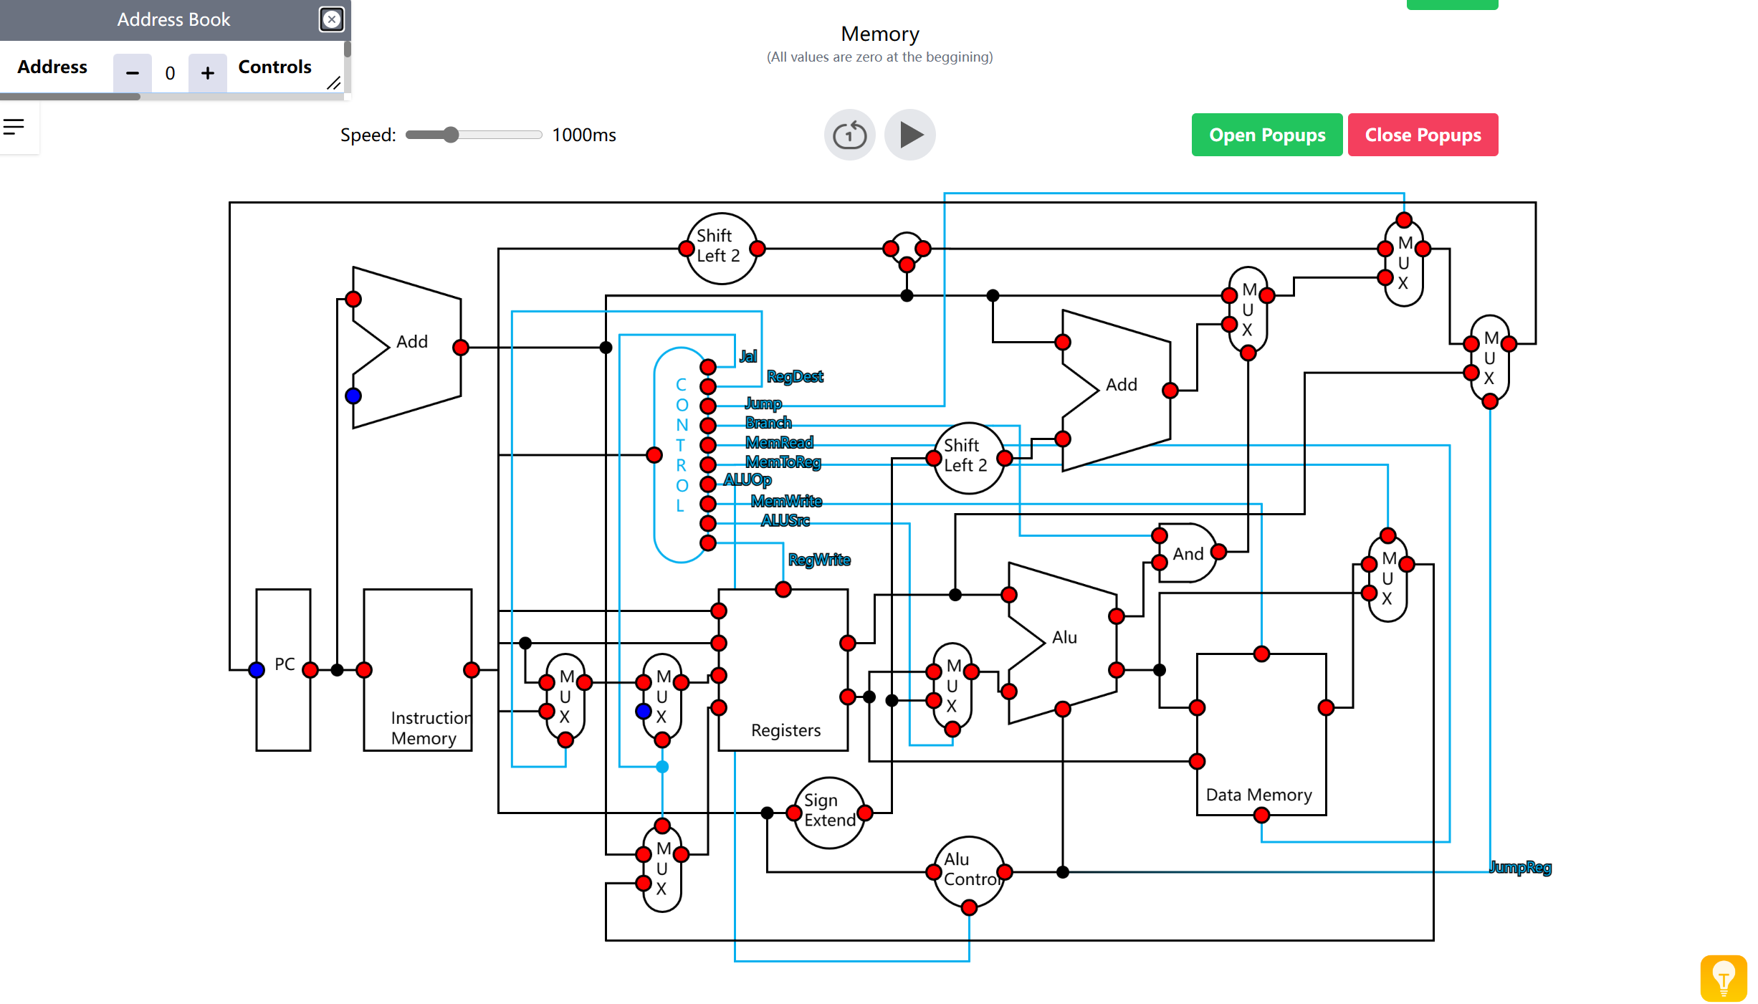
Figure 11: Screenshot of Mips-simulator
The above images are screenshots of the program. This product is a perfect representative of demonstrating the simulation of a computer system. It involves 32 registers and over 220 memory addresses, which are sufficient for any level of operation complexity. The value in each memory address is shown in a list on the side. If the pointer hops over the node, its value will be displayed on the top of the nodes. Additionally, the wire and components used when executing an instruction are highlighted. Complementing the visualisation, it also has a powerful assembler which supports most of the instructions implemented in modern computers. Furthermore, in terms of user interface design, the instructions on each function are presented clearly, which allows users to easily handle the simulator with no training and rare prior knowledge.

However, the simulator is only suitable for advanced computing learners who have a solid understanding of the fundamentals of computers. Its unorganised and complicated data path design will confuse beginners because it is tough to sort out the role of each component in each execution stage and the connections between them. Apart from the rough design, the program does not support directing to a specific memory address, which takes a long time for the user to scroll through the memory address list and find the expected memory address. A lack of manual determining what each instruction does could also lead to a disaster experience for users.

Little Man Computer
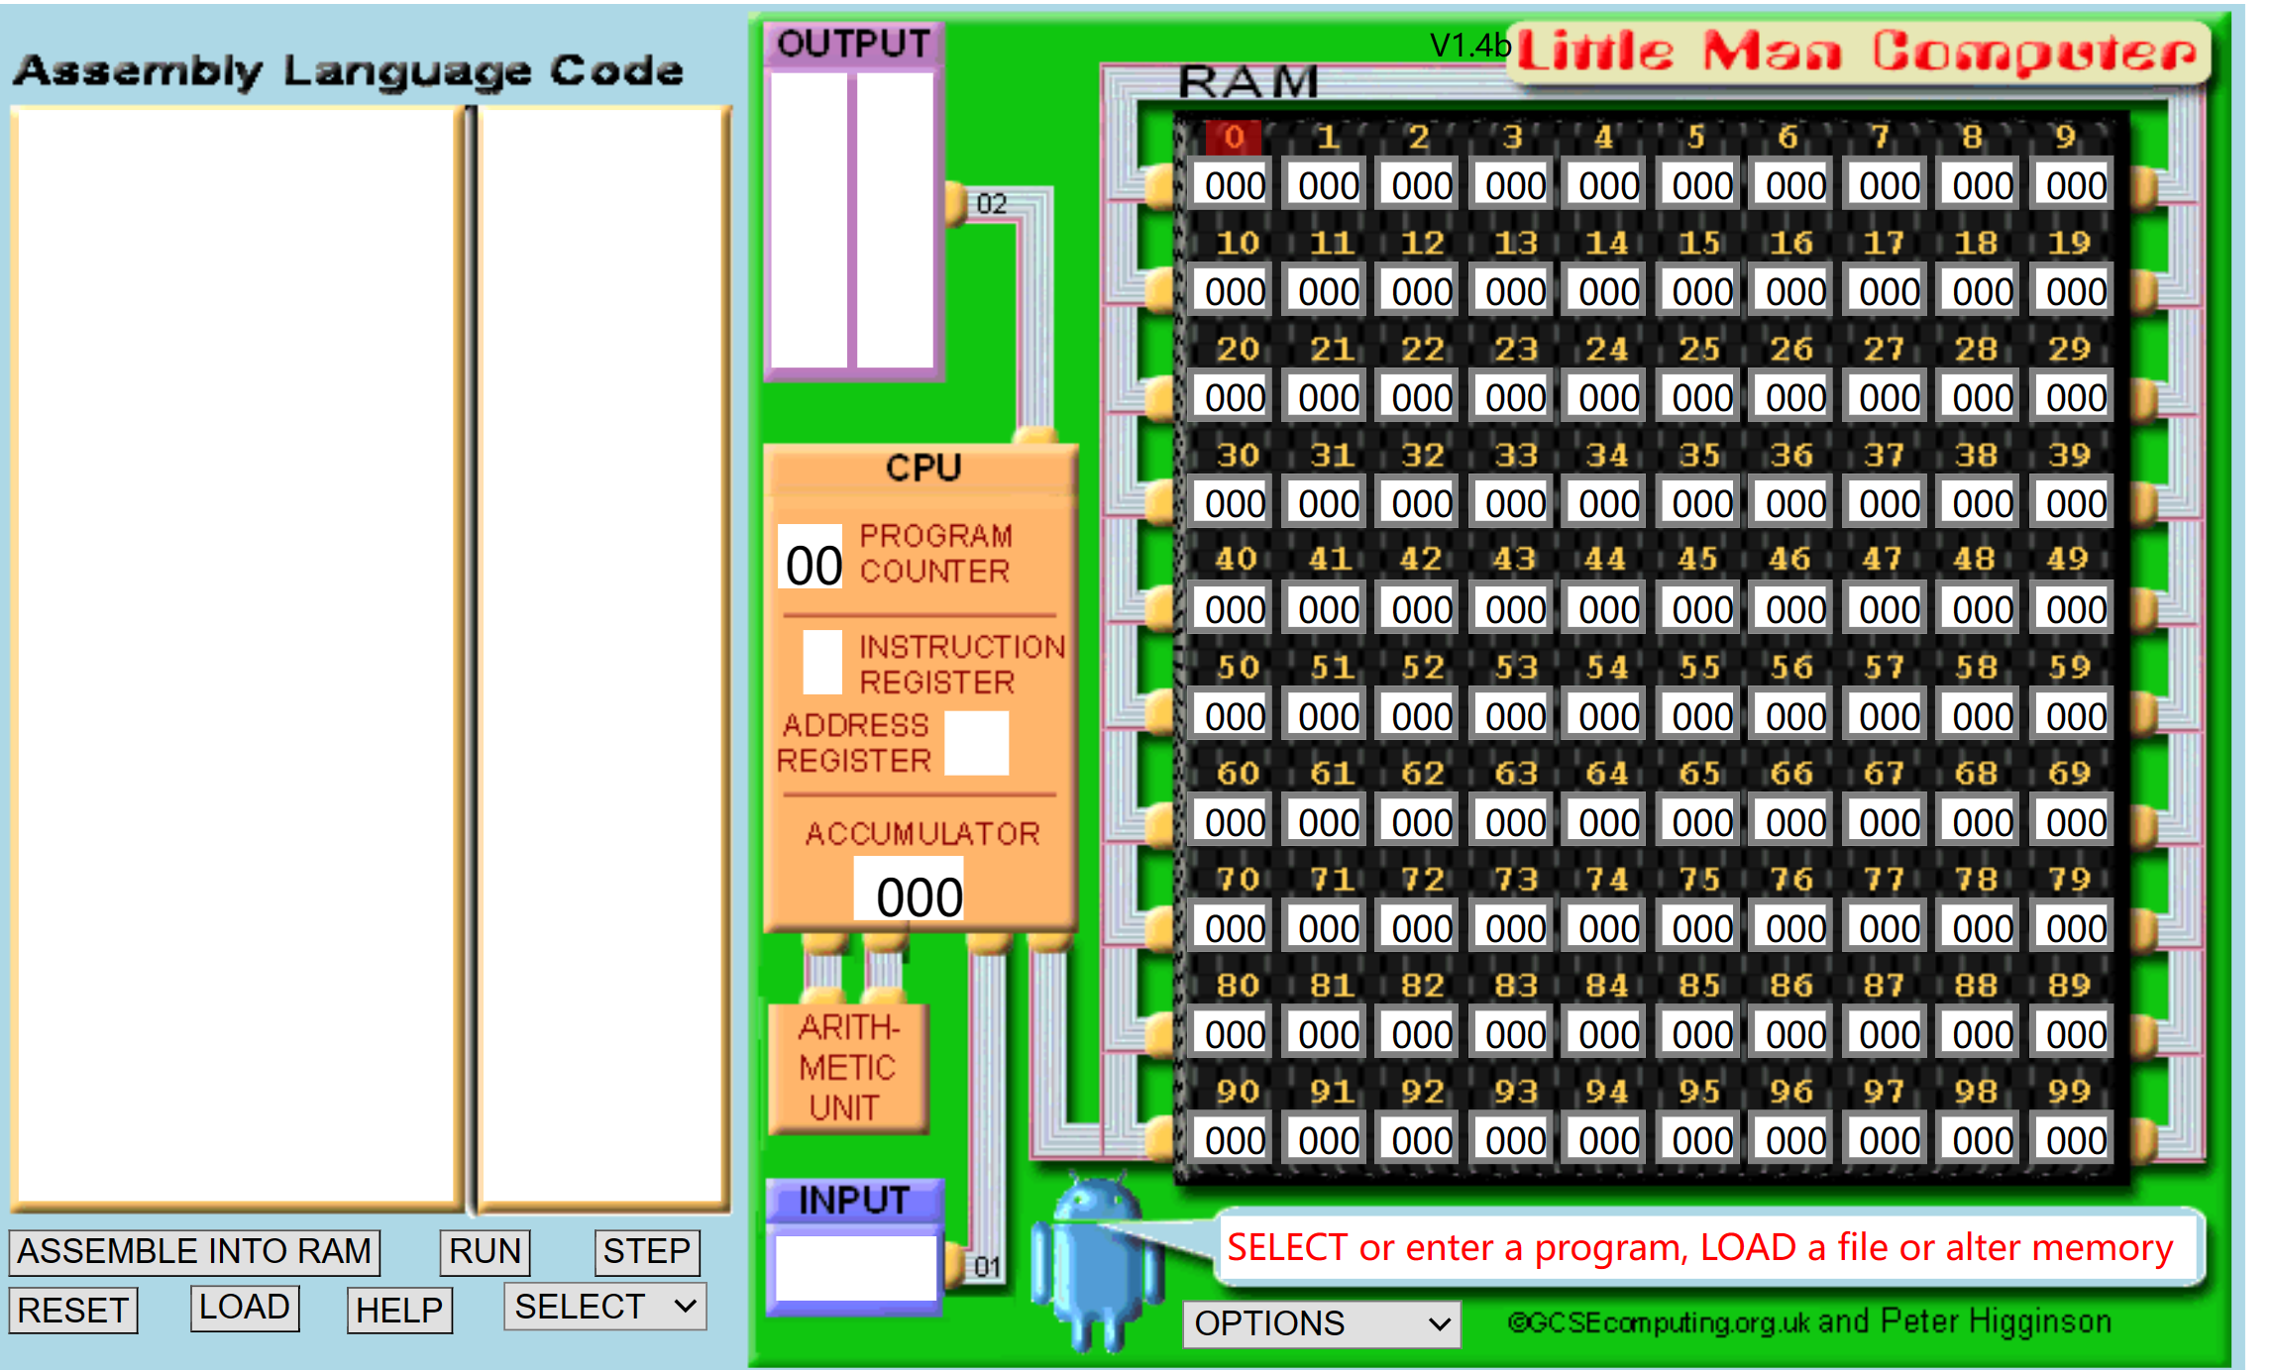
Figure 12: Screenshot of Little Man Computer
The screenshot shows a computer system simulator designed for basic-level students. Only 100 memory addresses are involved in the system, and an over-simplified CPU and Arithmetic Logic Unit are implemented, leading to limited functionality. In this case, it did barely any illustrations on the registers and data path level. Moreover, the program has no freedom at writing assembly code by users. As a result, students pursuing high standards attainment might find the product not as efficient as the previous example.

